**How to Install AutoCAD Mechanical 2021 Software In Microsoft Window 10**

1. Run the setup. “Setup Initialization”

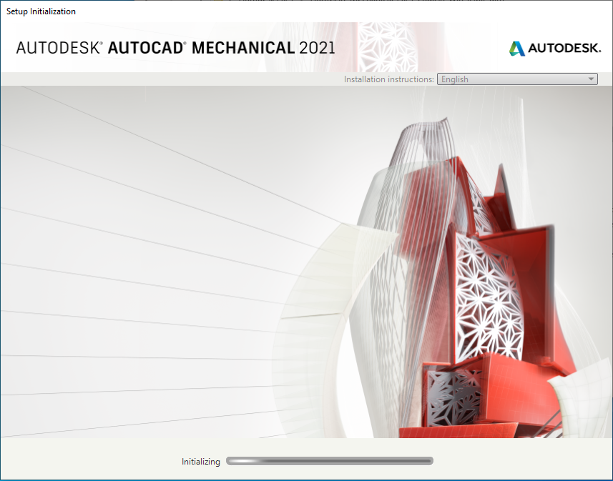

1. Click on the “Install” button.

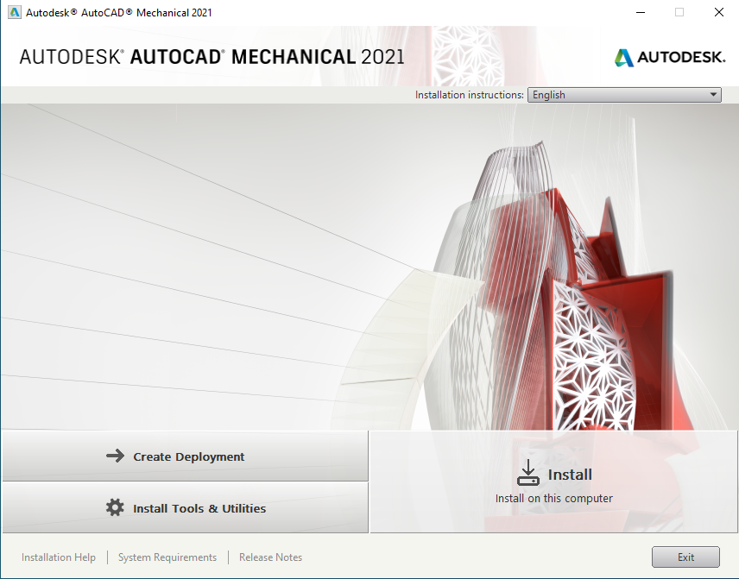

1. Select “I Accept” and Click on the “Next” button.

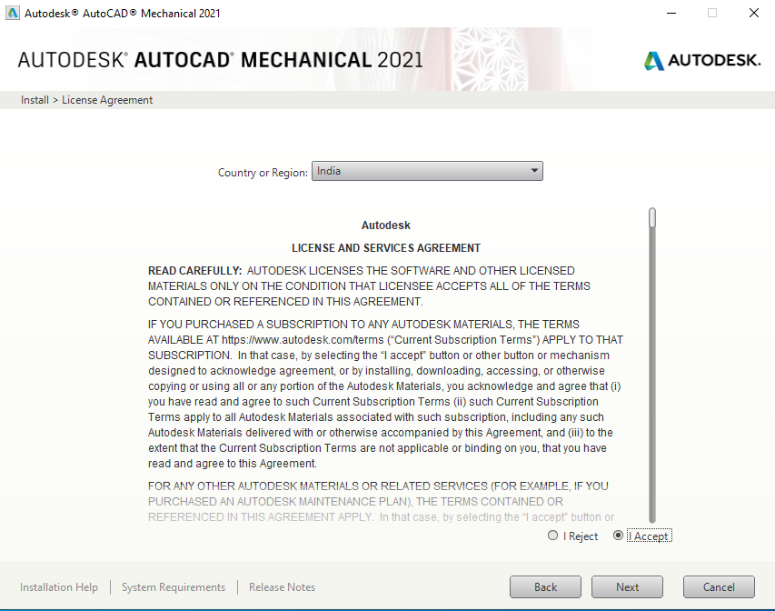

1. Check “Configure Installation” and “Installation path automatic select” and Click on “Install” button.

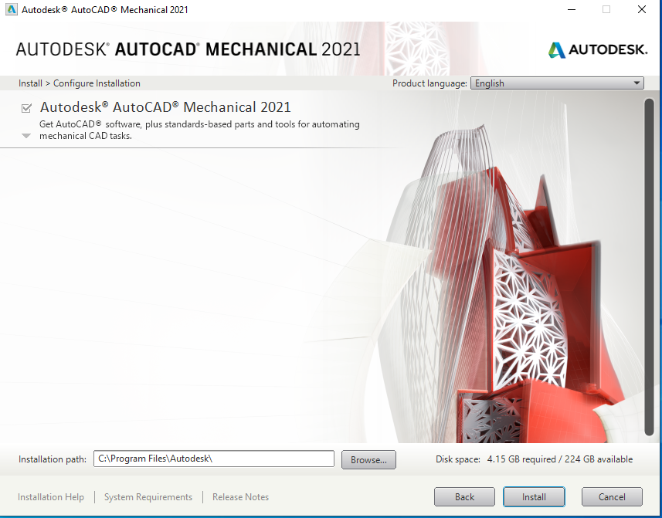

1. Wait several minutes for AutoCAD Mechanical installation complete.

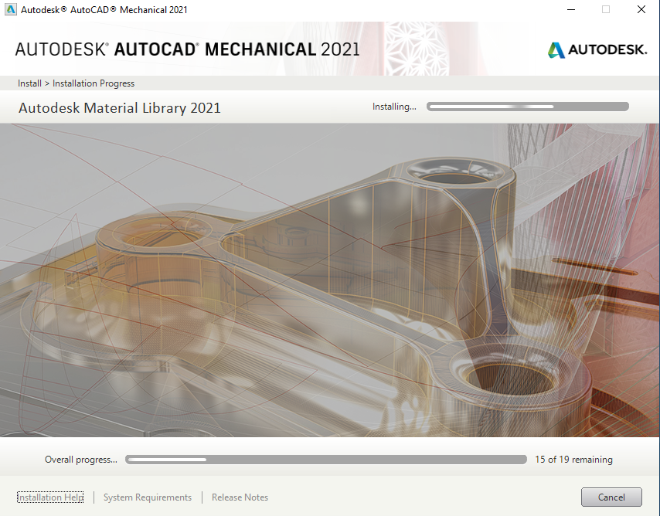

1. AutoCAD Mechanical installation completed. And Click on “Launch Now” button.

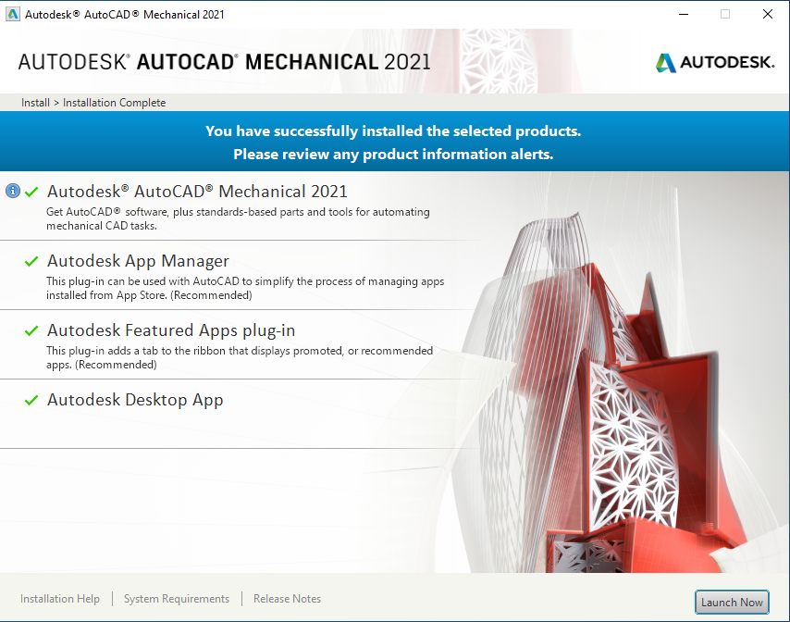

1. Open the AutoCAD Mechanical 2021. Enter the “Network Licence” **(The Network Licence for IIT Campus is 172.31.1.12).** Then Click on “Select” button**.**

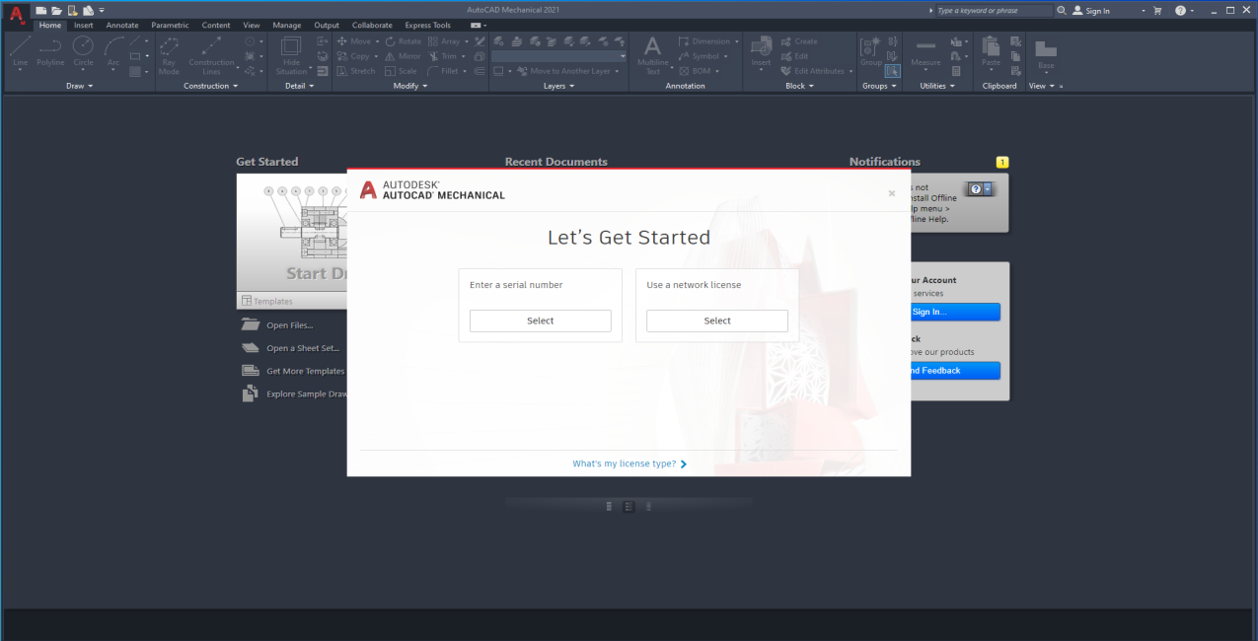

1. Select a “Single Licence Server” and enter the Server Name IP Add 172.31.1.12 and Click on the “Done” Button.

